**AWS Task-4**

* EC2 instance without attaching additional 5GB EBS Volume:

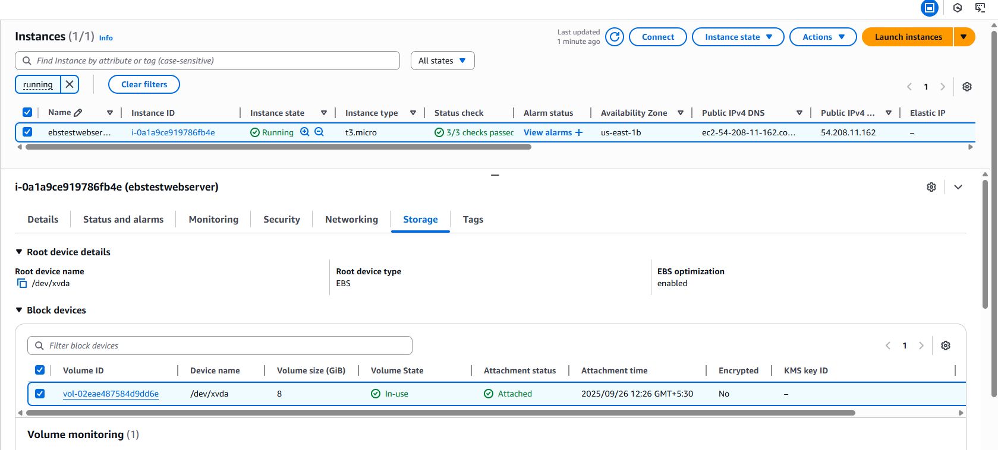

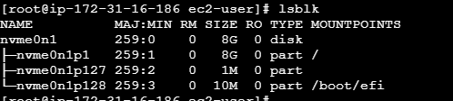

* 5GB EBS Volume:

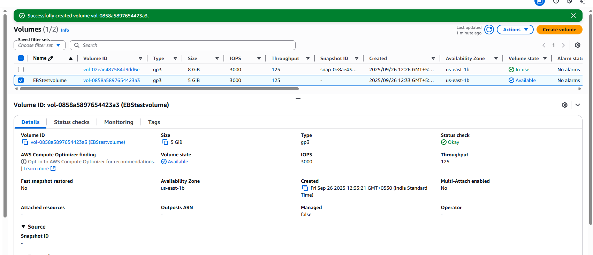

* Newly attached 5GB Volume to the instance:

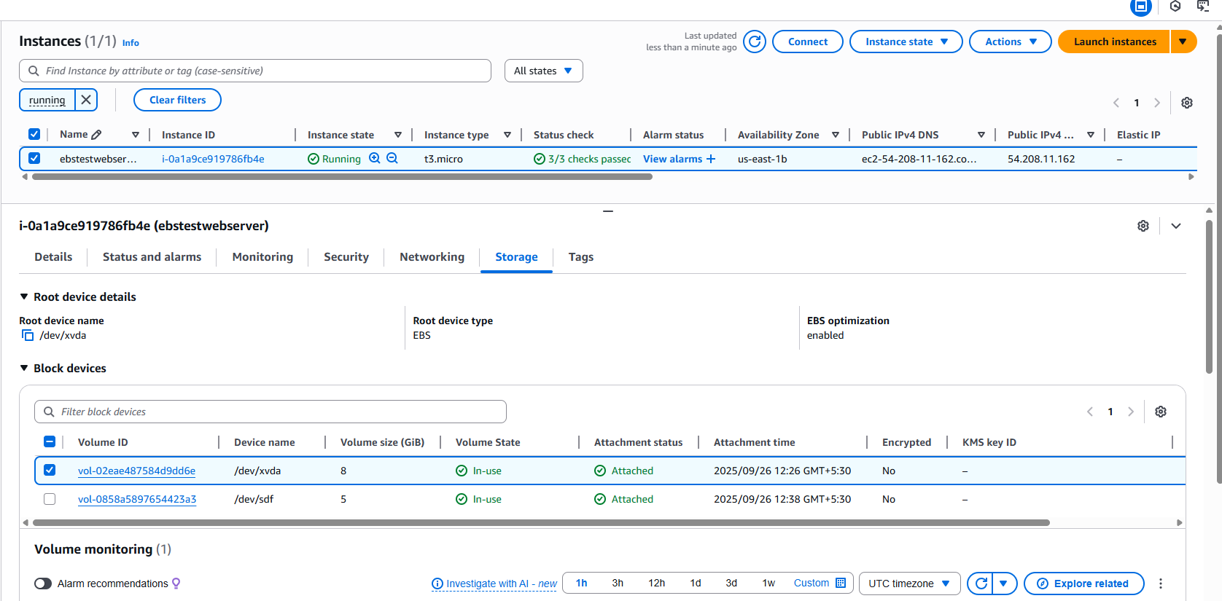

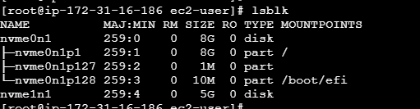

* Snapshot created from 5GB EBS

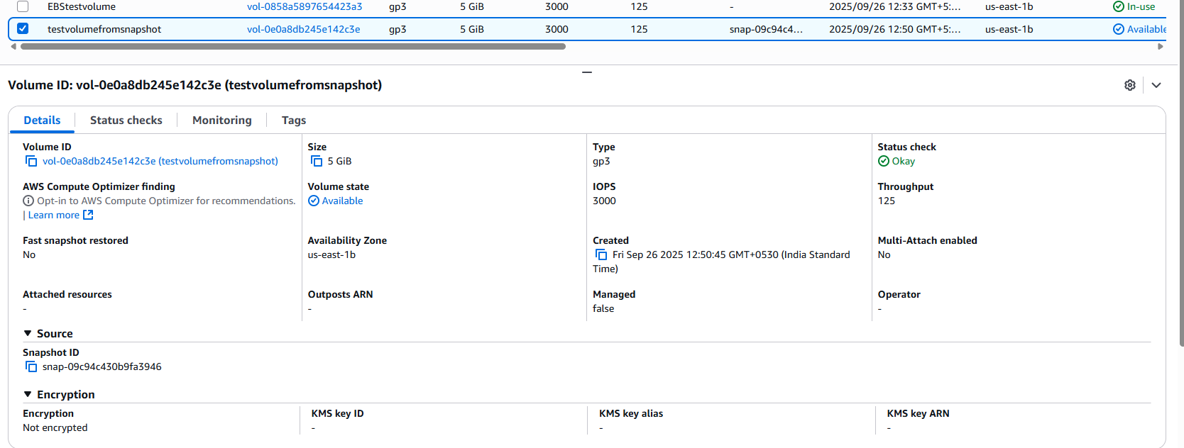

* EBS Volume created from Snapshot:

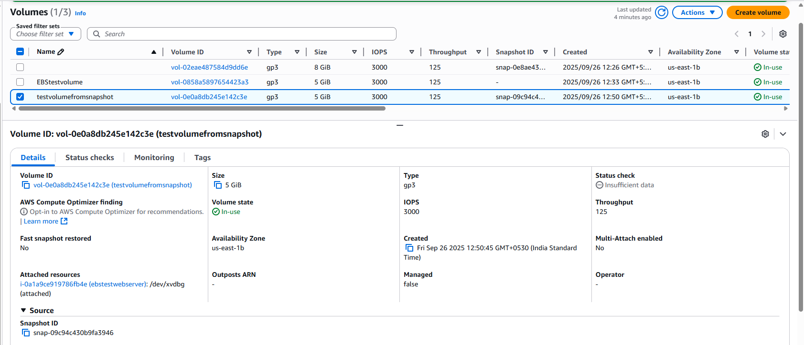

* New EBS volume attached to instance:

